Pizza sales SQL queries
Select all from table
select * from pizza_sales
- KPI’s

- Total Revenue generated.

select SUM (unit_price) as total_revenue from pizza_sales
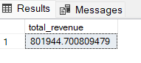
- Average order value
select (SUM (total_price) / COUNT (DISTINCT order_id)) AS Avg_order_value FROM pizza_sales
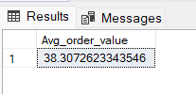
- Total pizza sold
select SUM (quantity) AS Total_pizza_sold from pizza_sales
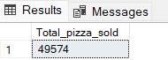
- Total order
select COUNT (distinct order_id) as Total_order from pizza_sales
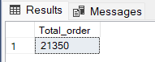
- Average pizza per order
select CAST(SUM(quantity) AS DECIMAL(10,2)) / CAST(COUNT(DISTINCT order_id) AS DECIMAL(10,2)) AS avg_pizza_per_order from pizza_sales
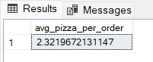

- Daily trend for total order
SELECT DATENAME (DW, order_date) as order_day, COUNT (DISTINCT order_id) AS To tal_orders FROM pizza_sales
GROUP BY DATENAME (DW, order_date)
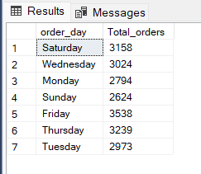
- Hourly trend for total order
select DATEPART (HOUR, order_time) AS order_hour, COUNT (DISTINCT order_id) AS total_orders
from pizza_sales
GROUP BY DATEPART (HOUR, order_time)
ORDER BY DATEPART (HOUR, order_time)
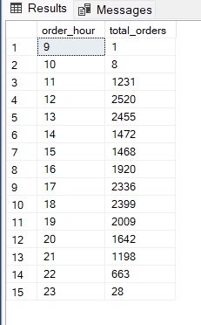
- Percentage of sales per pizza categories
select pizza_category, SUM (total_price) * 100 / (select SUM (total_price) from pizza_sales)
from pizza_sales AS total_sales
GROUP BY pizza_category
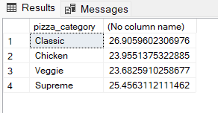

- Total pizzas sold by pizza category
select pizza_category, SUM (quantity) as Total_pizza_sold
from pizza_sales
Group by pizza_category
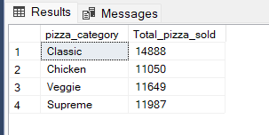

- Top 5 best sellers by total pizza sold
select TOP 5 pizza_name, SUM (quantity) as Total_pizza_sold
from pizza_sales
GROUP BY pizza_name
ORDER BY SUM (quantity) DESC
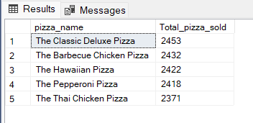
- Bottom 5 worst sellers by total pizzas sold
select TOP 5 pizza_name, SUM(quantity) as Total_pizza_sold
from pizza_sales
GROUP BY pizza_name
ORDER BY SUM(quantity) ASC
